# *AWS LAMBDA FUNCTION LAB DOCUMENTATION*

* **What is AWS Lambda?**
* **AWS Lambda is a serverless computing service that lets you run your code without managing servers. It allows you to execute code in response to events**

**Step-by-Step Procedure**

**Step 1: Create a Lambda Function**

* **Log in to the AWS Management Console.**
* **Go to Services and search for “Lambda.”**
* **Click on “Create function.”**
* **Choose “Author from scratch.”**
* **Enter Function Name: Lambda1**
* **Select Runtime: Python 3.9 (or your preferred runtime)**
* **For Role, select “Create a new role with basic Lambda permissions.”**
* **Click “Create function.”**

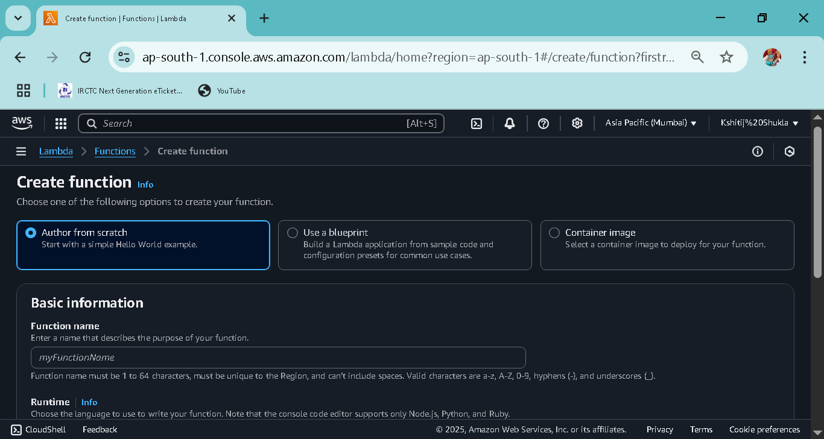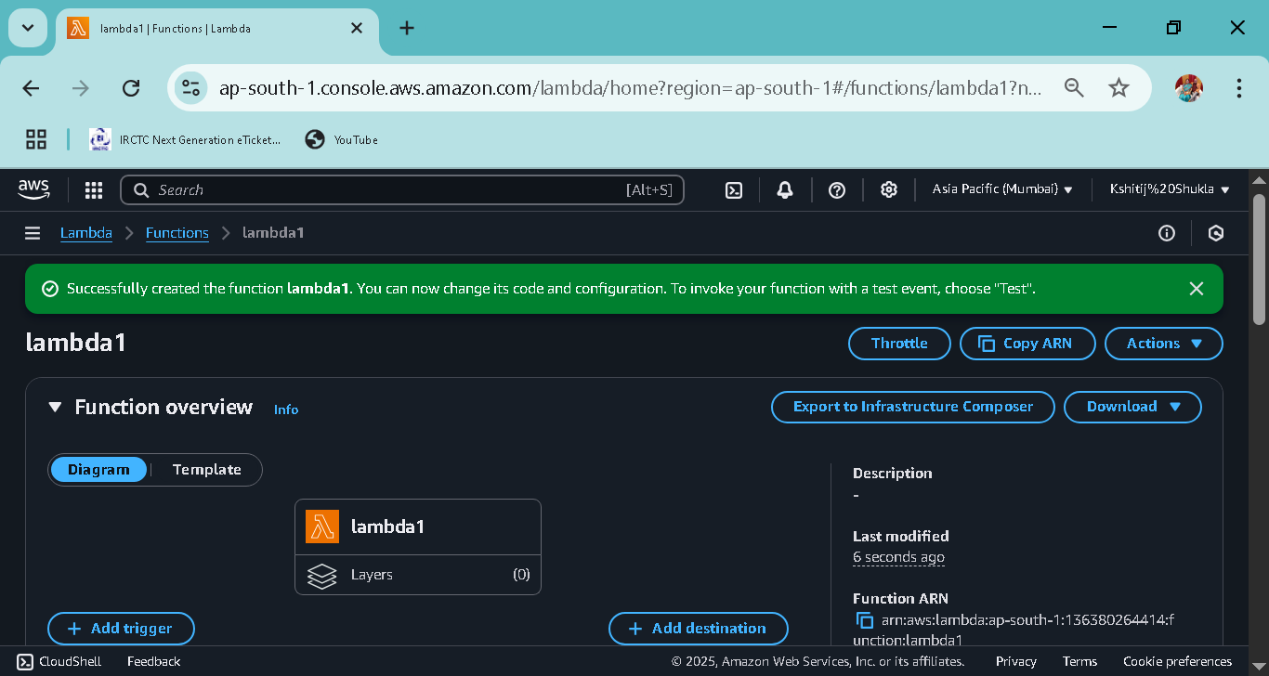

* **Step 2: Write the Code**
* **In the Lambda function code editor, enter the following code:**
* **Default code** 🡪

**def lambda_handler(event, context):**

**return {**

**'statusCode': 200,**

**'body': 'Hello from Lambda!'**

**}**

* **Go to code section**🡪

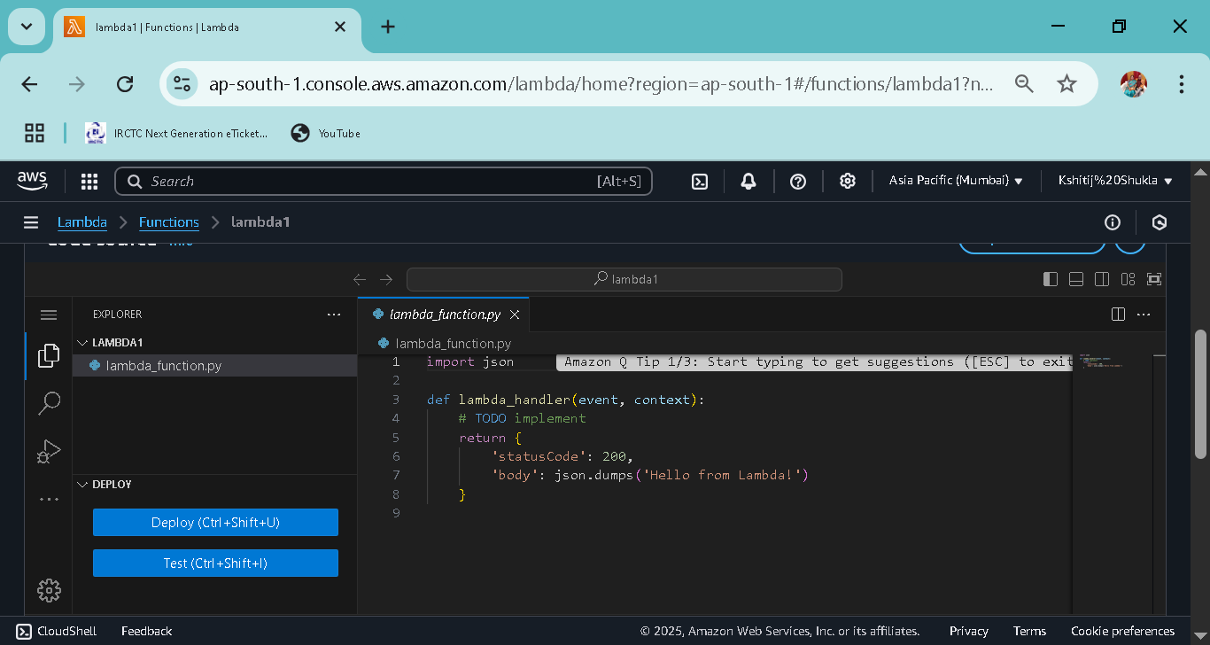

**Step 3: Create a Test Event and Test the Function**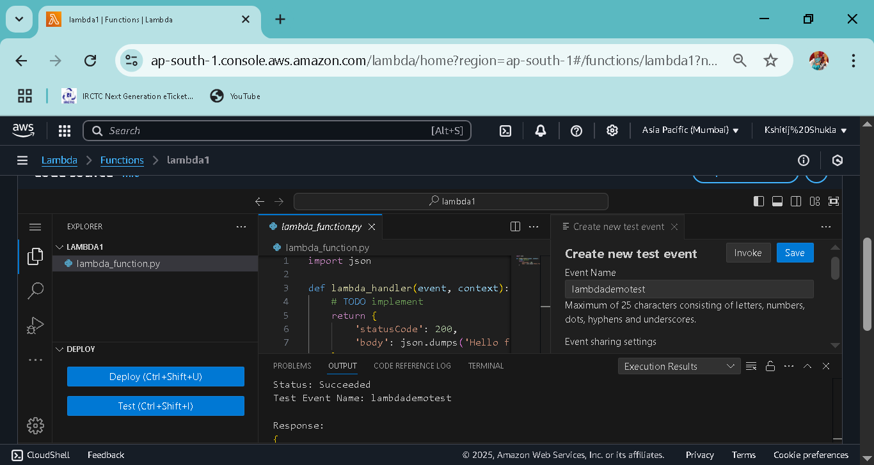

1. **Click the “Test” button.**
2. **Create a new test event (you can leave the default settings).**

**3. Give the event a name and save it.**

**4. Click “Test” again.**

**5. You will see the output “Hello from Lambda!**

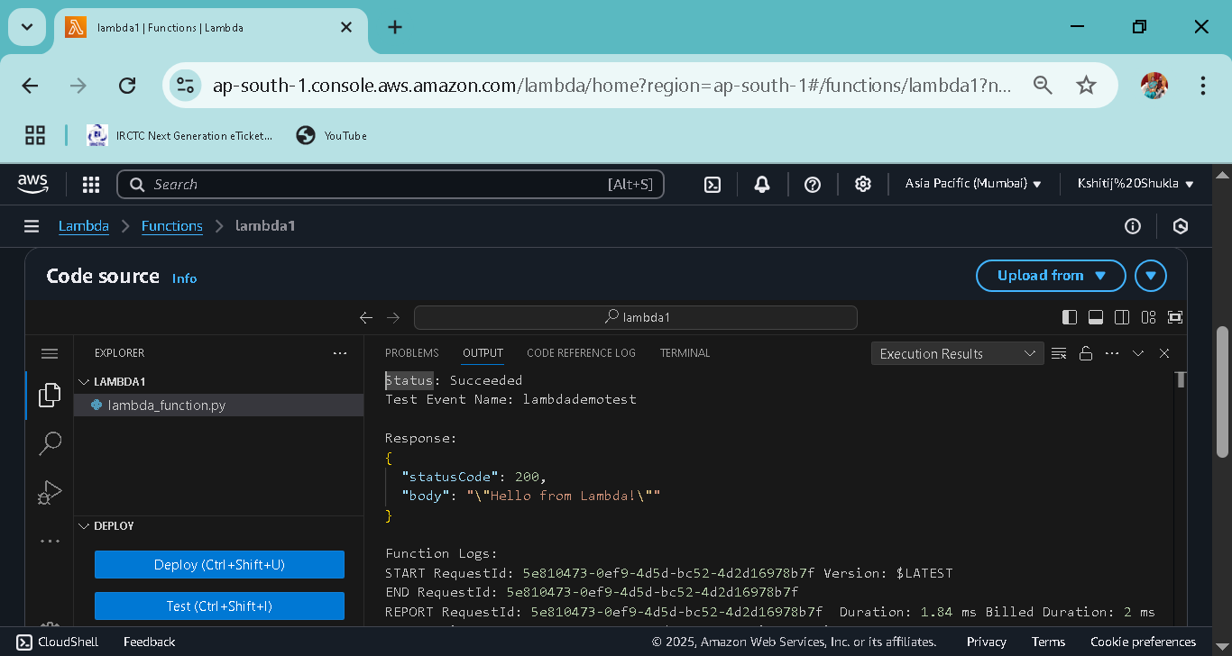

**Step 4: View Logs**

**1. In the Lambda dashboard, go to the “Monitor” tab.**

**2. Click “View logs in CloudWatch.**

**3. You can see the execution logs there.**

**Step 5: Add a Trigger (Optional)** 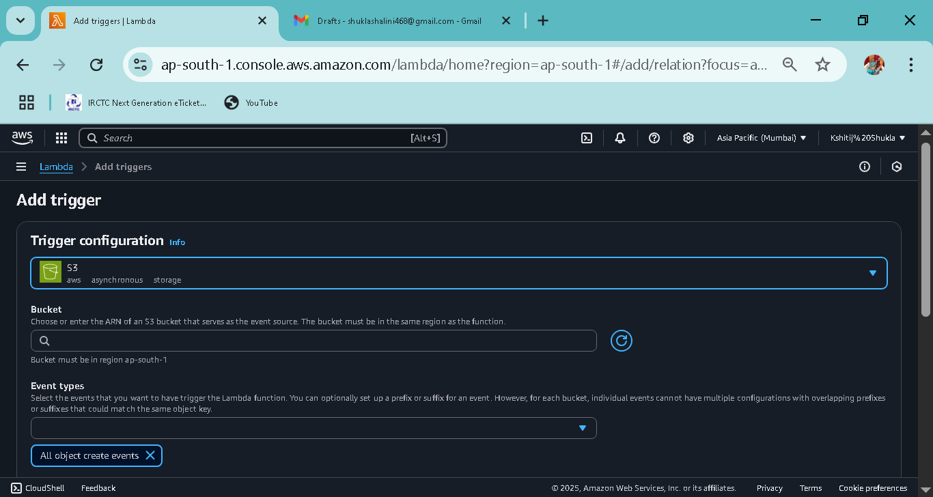

**1. Go to the “Configuration” tab.**

**2. In the “Triggers” section, click “Add trigger.”**

**3. Select any service like S3, API Gateway, etc.**

**4. Configure the trigger and save.**

**(make sure if you add s3 in the trigger then ,S3 bucket wants to be created!)**

**Its means you can see your trigger in the Lambda Function.**